Summary of AI Developing Kits

I.Overview: Artificial intelligence (AI) has become ubiquitous in our daily lives, with autonomous self-driving cars and vacuum robots being just a few examples. However, the rise of AI is also expected to cause significant job displacement, with up to 600 million jobs lost (-22%) and 700 million jobs created (+25%) by 2030, according to research.
To leverage the power of AI, it is important for developers and management in our industry to explore various AI development tools that do not require extensive skills. Unfortunately, many such tools are underutilized, leading to a lack of insight in the industry.
In this section, we will focus on the most popular AI tools provided by Microsoft for data driven working with tables, text, audio, images, and video. We will not cover Amazon, Google’s API. We will also explore how to incorporate AI to automate out products and services into our products and services.
The section assumes some basic knowledge of Python programming. There is no prerequisites on math, complicated code or statistics. However, the idea is that the pre-trained machine leaning is already on the cloud, our application running on server or pc that will feed the new input to the model on the cloud and get the result back via simple API call or REST without reinvent the wheel by writing a machine learning algorithm. To achieve this, there is a certain setup steps to go through.

II. Distinction between Machine Learning and Artificial Intelligence
Machine learning is learning how to solve problems without explicit program to do so. It meant to be the algorithm where it analyzes the input and produce the most possible output.
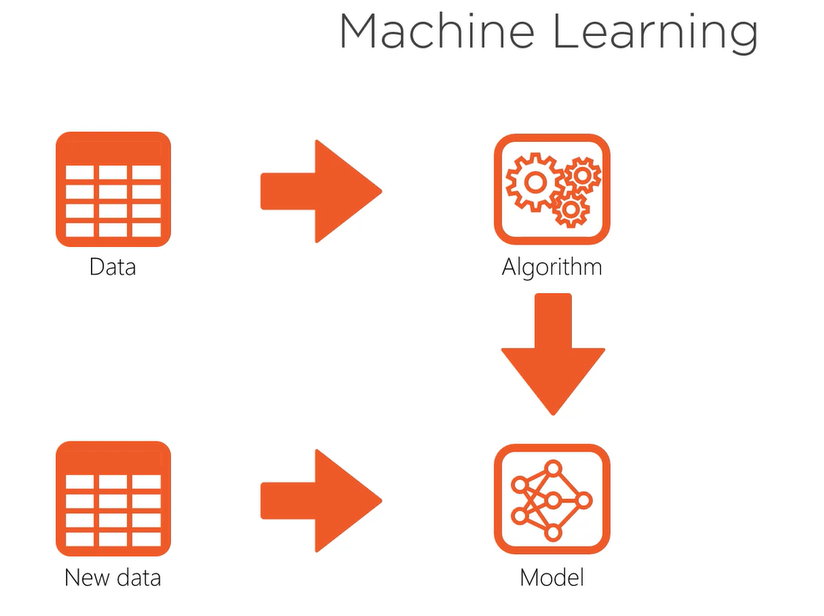

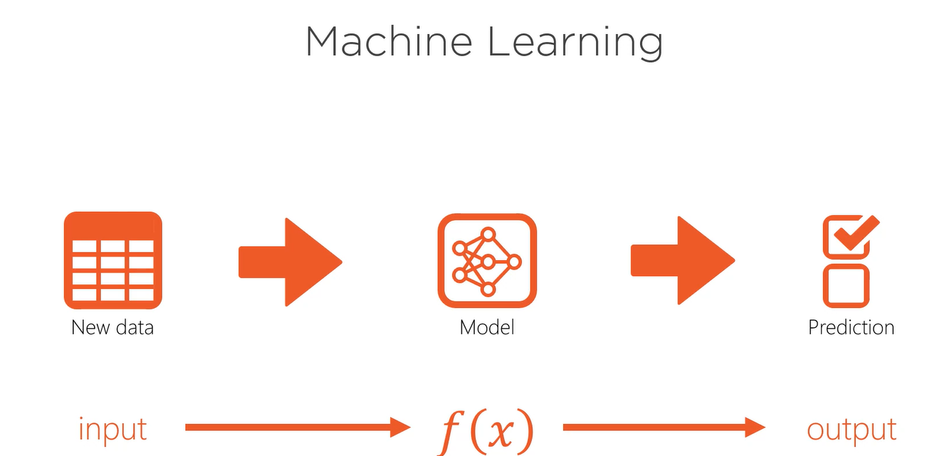

Artificial intelligence (AI) is increasingly being used in various applications to replicate human intelligence or natural language. Some examples include:
In Netflix, AI analyzes our watching history and recommends movies with similar content based on how often we watch certain types of movies.
In retail, AI uses sales data to suggest similar most selling products for customers to buy and for operators to add to their product catalog.
In software development, AI is used to automate testing processes. For example, when a developer commits a change, the build kicks off to build and run auto tests. If any test fails, the system emails the log to the developer for further investigation.
In biometrics, AI can recognize a user's fingerprint and trigger a pop-up with a new version of a policy that the user needs to read and register their fingerprint again.
Overall, AI relies on machine learning techniques to perform these tasks and improve their accuracy over time.
III. Type of AI Toolkit’s
There are 3 types of machine learning model that pre-trained model, augmented model, and custom model. In our training we focus on the AI that use Pre-trained Model (off the self) and augmented model by learning and applying it from Google, Amazon, and Microsoft.
We will be looking Microsoft Client SDK, Microsoft REST API, Google Client SDK, Google REST API, Amazone Client SDK.
IV. What type of data the AI Tookits Support
- Ai for Text : azure.ai.textanalytics, detect_language, extract_key_phrases, recognize_entities, analyze_sentiment_with_opinion_mining
- Text analysis, which can involve text classification, sentiment analysis, and entity recognition.
Example: This is useful for categorizing documents or emails, prioritizing defects and user stories to work, filtering out impolite conversations in chat or conversation, and automate the research process.
- Text synthesis, which can include text completion, text generation, and language translation.
Example: Text completion can predict missing words in a sentence, while text generation can automatically generate FAQ support from support tickets. Language translation can convert text from one language to another, such as from English to Spanish.
- Code Demo (see mini program)

- Ai for Audio: azure.cognitiveservies.speech Artificial intelligence (AI) can also be used to analyze audio data. This includes:
- Audio Analysis:
Sound classification, which can identify and categorize different types of sounds, such as a dog's bark or a car horn.
Speaker recognition, which can identify the speaker based on their voice.
Speech recognition, which can transcribe spoken words into text. This is useful for applications like TV captions or translating speech to text.
- Audio Synthesis: speech synthesis, voice synthesis and speech translation
Speech synthesis, which can convert text to spoken words. This is useful for applications like pronunciation guides.
Voice synthesis, which can create synthetic voice recordings that sound natural. This can involve using a source voice to edit a person's voice in an audio recording and updating the voice synthesis model to produce a more accurate or natural-sounding voice.
Speech translation, which can translate spoken words in real-time from one language to another. For example, it can translate from English to Spanish.
- Code Demo (see mini program)
- Ai for Images: azure.cognitiveservices.vision
- Image Analysis: Image classification, Object detection, face recognition
Image classification, which can identify objects and scenes in a picture. This can be used for applications like diagnosing skin cancer or identifying animals in wildlife photography.
Object detection, which can locate objects in an image and provide a bounding box around them. This can be used, for example, to locate items in an image of a cluttered desk.
Face recognition, which can identify individuals in an image or video. This can be used for security applications, or for organizing large collections of photos.
- Image Synthesis: Image completion, Image generation, Image style translation.
Image inpainting, which can fill in missing content in an image. For example, it could replace a part of an image that has been damaged or filter out a certain object in the picture.
Image generation, which can create new images based on a short text description. This can be used for applications like generating product images for e-commerce sites.
Style transfer, which can combine the content of one image with the style of another to create a new image with a unique look.Code Demo (see mini program)
- Ai for Video: Teachable Machine without a single line of code
- Video Analysis: Motion detection, object tracking, action recognition
Ex: Is there anything moving? Given input video, the model detects pedestrian walking…
Ex: how does the object moving? Given input video of object moving, the model track with bounding box for each move of object. Following the face of pedestrian walking
Ex: What happen next in the video? Given input video, the model produces output of pedestrian is walking, running, exercising, waving, speaking….
- Video Synthesis: Video interpolation, Video prediction, Video-Video transfer
Ex: If there are missing video frames in the video, we can use AI to determine what content is missing. For example, in ultrasound, the tissue (B image frame) has a higher frame rate, say 40fps, than the color frame (blood flowing), which has a frame rate of 20fps. The data is more complex, so it captures and processes slower. The AI model can interpolate the missing color frames to pair each B frame with a composite image or smooth out some old movies where the captured image is disconnected and jerky in motion.
Ex: Given the current input video, the model predicts the next 30 frames of the video and the future movement. This helps to determine what is likely the next image in the video.
Ex: Using some labeled video segments as input, the model can produce the entire video from scratch. For example, given a scenario where a criminal enters a house and the footage has some disconnected action, the AI model can construct the whole video and develop the story of the criminal's action inside the house to fill the gap.
- Demo (see mini program)
- Ai for Applications: CV2 (computer vision for image manipulation)
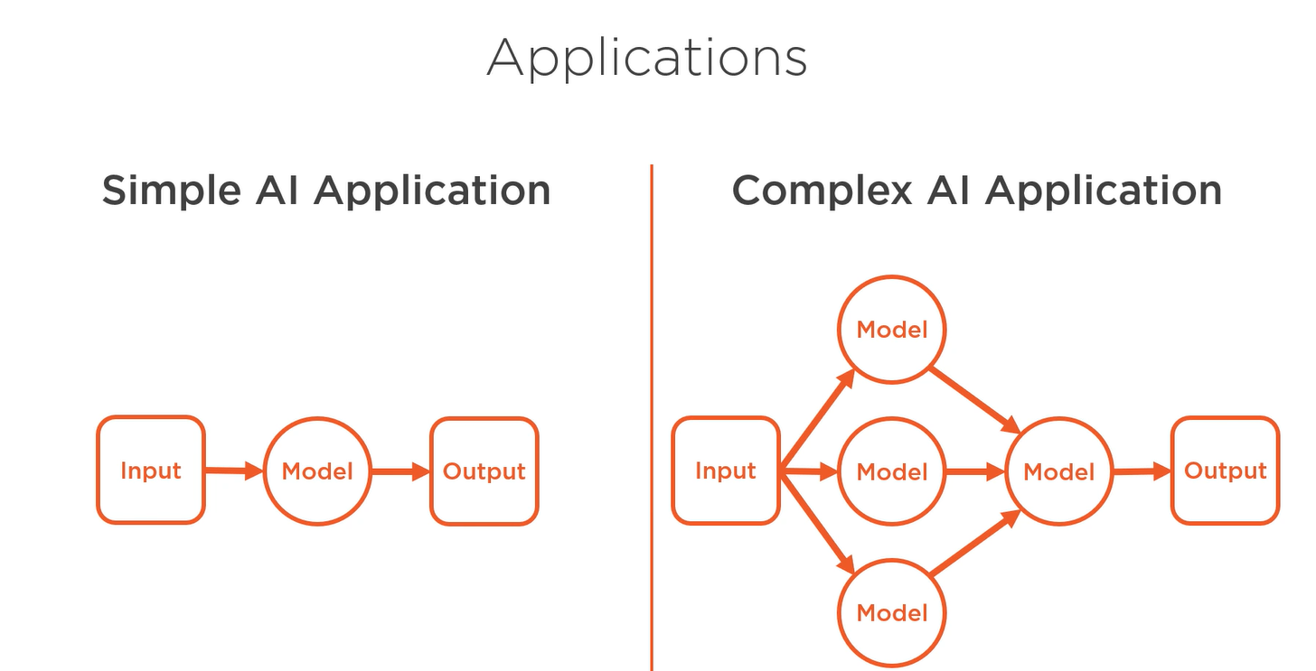
- Modular AI Applications
Training a model to map inputs to outputs can involve combining different models to improve predictions. For example, combining both image and text models can lead to more accurate estimations. Alternatively, we can use different models in different layers of abstraction, creating a chain of responsibility. For instance, one model can predict motion, while another can recognize objects, and together they can output a story from a video. Although this approach may require more code and expertise to implement, it is easier to debug, maintain, and extend over time.
- End-to-end AI Applications: It is a type of giant model that is built to perform all machine learning tasks at once, making it more powerful. However, creating, maintaining, and debugging such a model can be challenging.
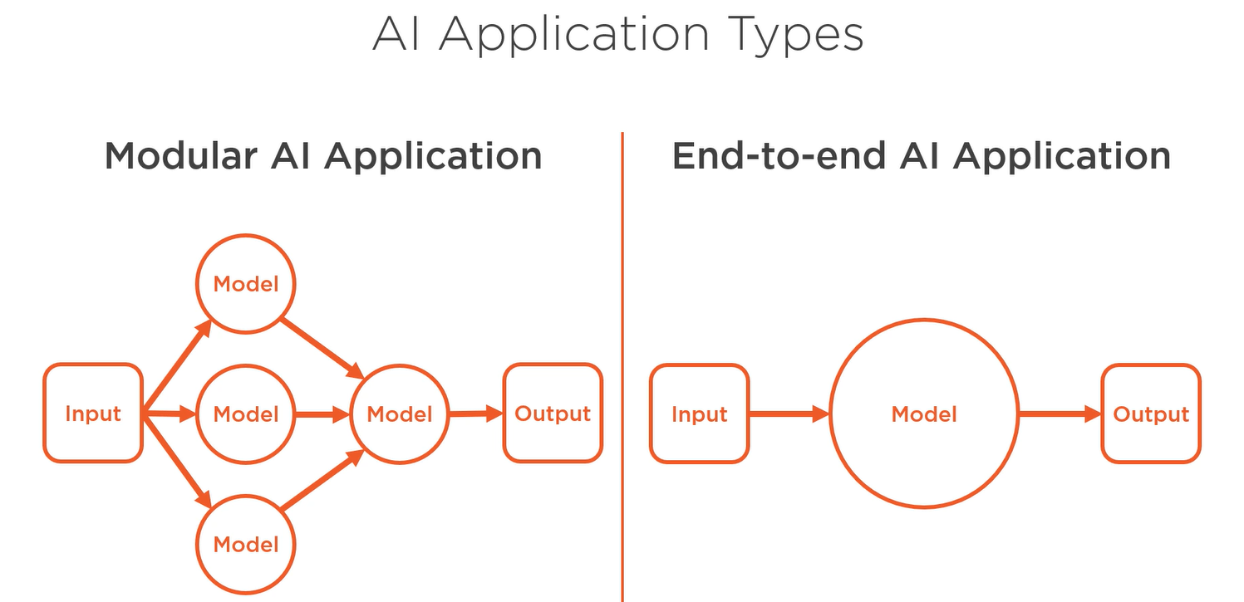

Code demo: Application that combine object classification by combine image detection plus visual classification. Combine two or more model in a way to solve the complex problem.
In order to use Microsoft tool kit for this, we need to create computer-vision resource on azure and import cv2. CV is stand for computer vision.

- Ai for System: Microsoft Bonsai
A cyber-physical system combines hardware and software to create an AI system that interacts with the physical world, such as robots, vacuum cleaners, and self-driving cars. The system senses its environment using sensors and converts the data into meaningful features. Then, it uses planning engines to develop a plan of action. The system learns and improves its decision-making by receiving feedback through rewards and punishments over time.
Example 1: Reinforcement learning can be illustrated with an example from ultrasound imaging, where we need to move the doppler gate region of interest (GUI) to the location of blood flow in order to measure the flow rate. The machine learning algorithm predicts the location of the region on the monitor and computes the current distance from the doppler gate to the flow position. It then sends an event to move the gate to that location instead of relying on the user to move it. However, as the user changes or tilts the transducer, the image also moves, affecting the position and angle of transmission and reception of the new image. Reinforcement learning in this case involves sensing the new data to produce new features and planning the next move to follow the movement of the flowing image and stay at the center of that image to produce accurate output. This requires a feedback loop where the output of one loop becomes the input of the next loop to continually update the accuracy of the input.
Example 2: We have developed a prediction model that forecasts the high and low stock prices for a company, and an AI application that automatically buys and sells the stock during the day based on those predictions. For instance, our model may predict that the low price for a given day will be $5.0 and the high price will be $6.5. If the market opens at $6.5, the system will use this information as feedback to determine its next move, such as whether to wait for the stock to decline towards $5.0 and then buy, or to sell later in the day. By continuously updating its predictions and actions based on market movements, the system aims to generate optimal returns for the investor.
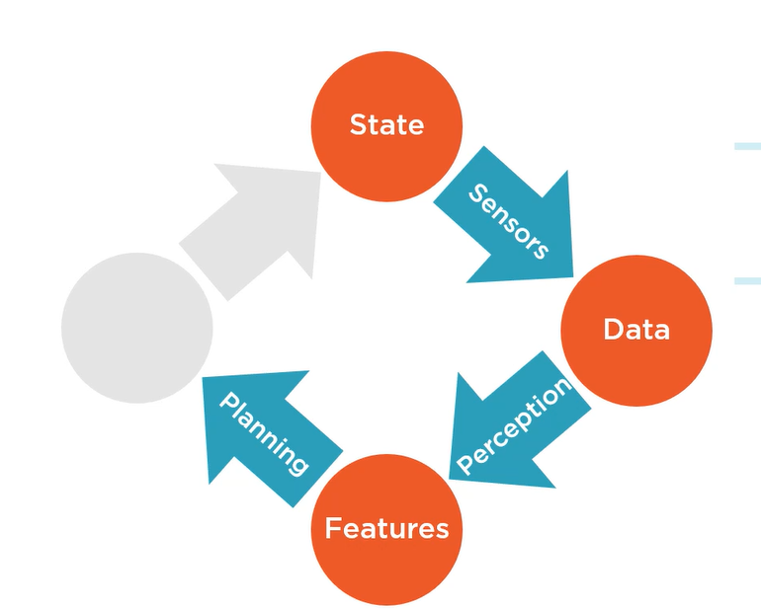

Code demo: To use Microsoft toolkit for reinforcement learning and machine teaching, we need to create Bonsai resource on azure.

